**Week 6 portfolio**

First of all, we installed Nessus in our Virtual Machine.

Then we went to Nessus website and login to our profile. There we had to install plugins before we could do a scan. Screenshot below shows the window during plugin install.

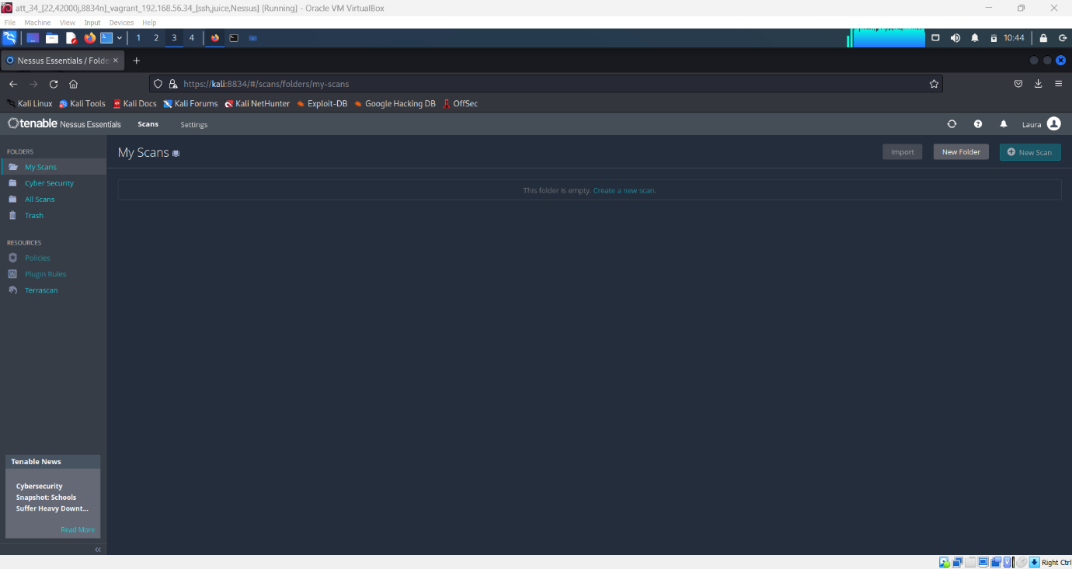

After some time, when plugins were installed successfully, we started setting up a scan. Screenshot below shows new scan set-up window.

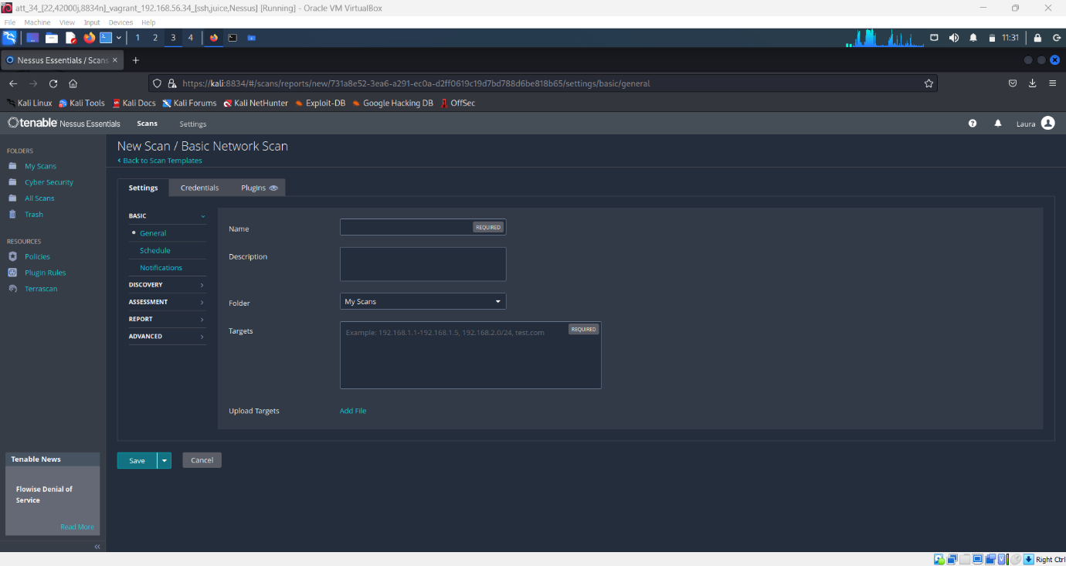

After everything was set-up and ready, we started the scan and had to wait for a while until the scan was finished. The image below shows the screen during the scan.

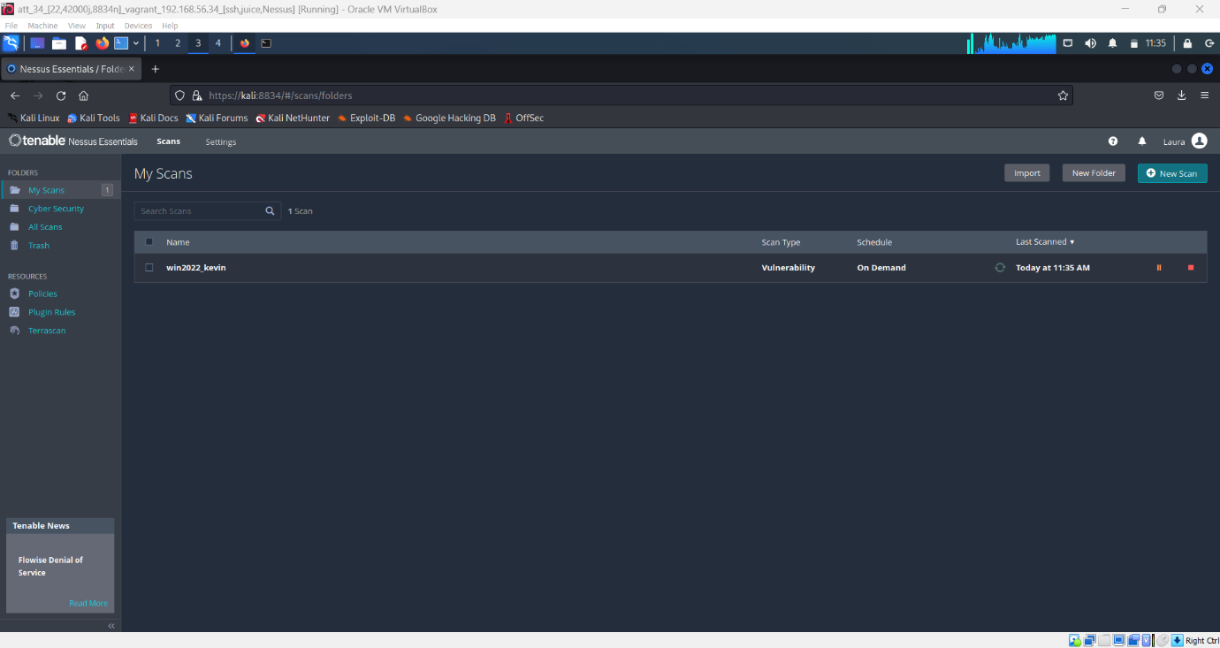

Down below you can see the results of the scan.

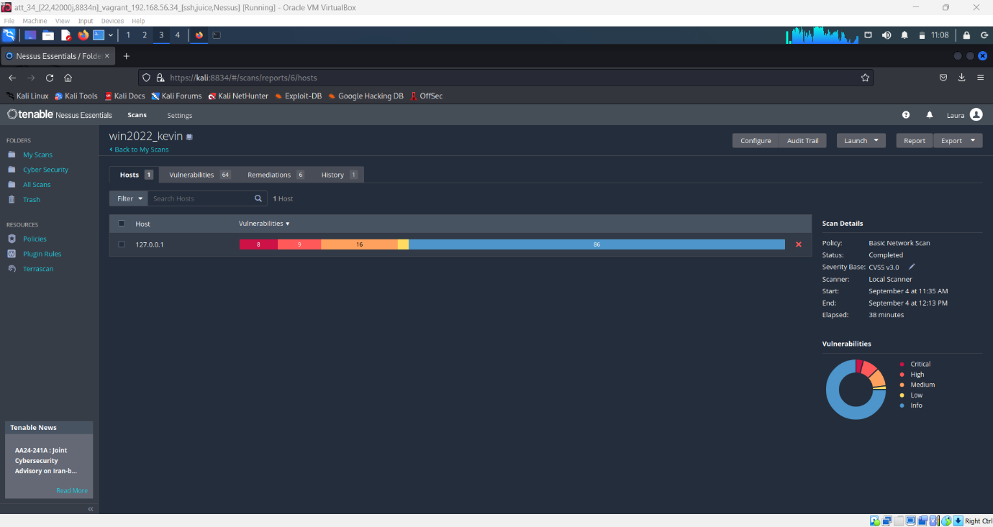

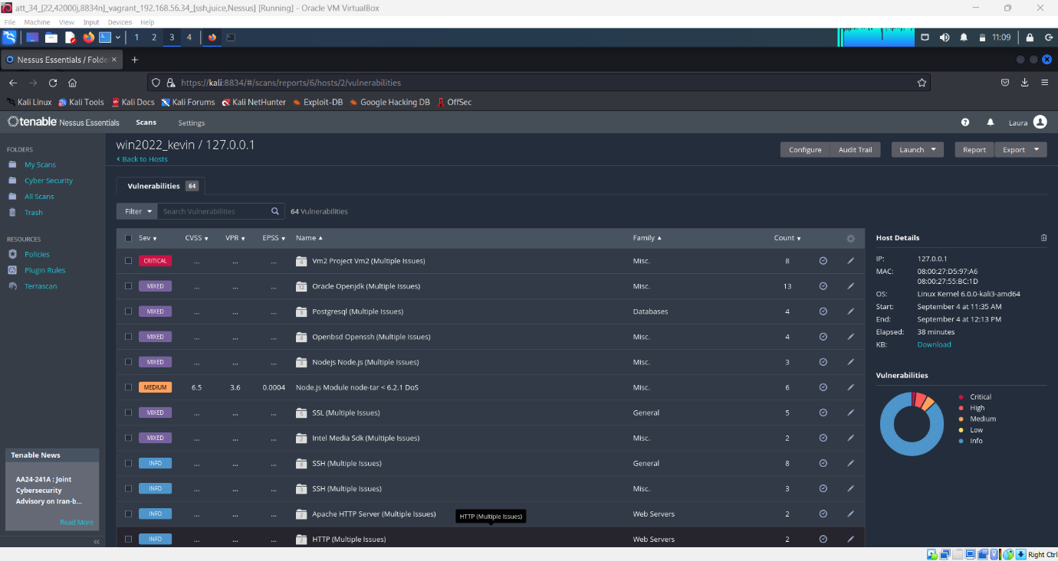

Afterwards, we successfully downloaded the pdf version of the scan results, following the instructions from portfolio handouts. Below, you can find the attached pdf file, which contains our scan results.

